INDIA'S AGRICULTURAL CROP PRODUCTION ANALYSIS

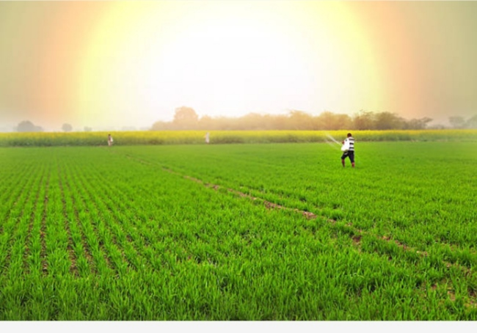

1. INTRODUCTION

1.1 OVERVIEW:

* Agriculture is an evolutionary process that consists of a series of activities such as the production of food ,fibers,feed,and raising of domesticated animals to fulfill the demand of the population.
* Agriculture is a key to development in the area of human civilization.

1.2 PURPOSE

* Agriculture is the foundation of the Indian economy.The population of india mostly depends on agriculture for their livelihood and agriculture contributes to 40% of the GDP of the country.
* Providing row materials for food and other products ; and building strong economies through trade.

2.PROBLEM DEFINITION & DESIGN THINKING

2.1 EMPATHY MAP

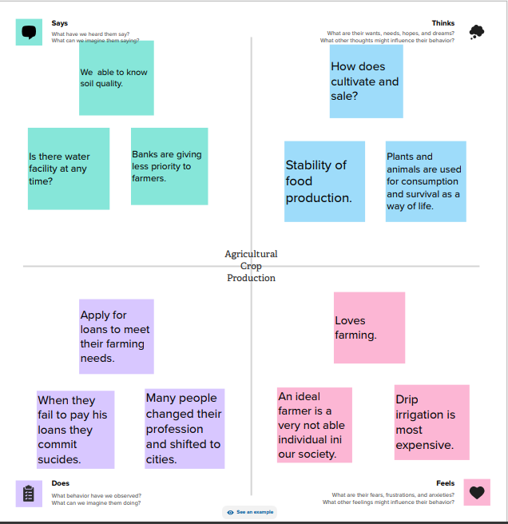

2.2 IDEATION & BRAINSTORMING MAP

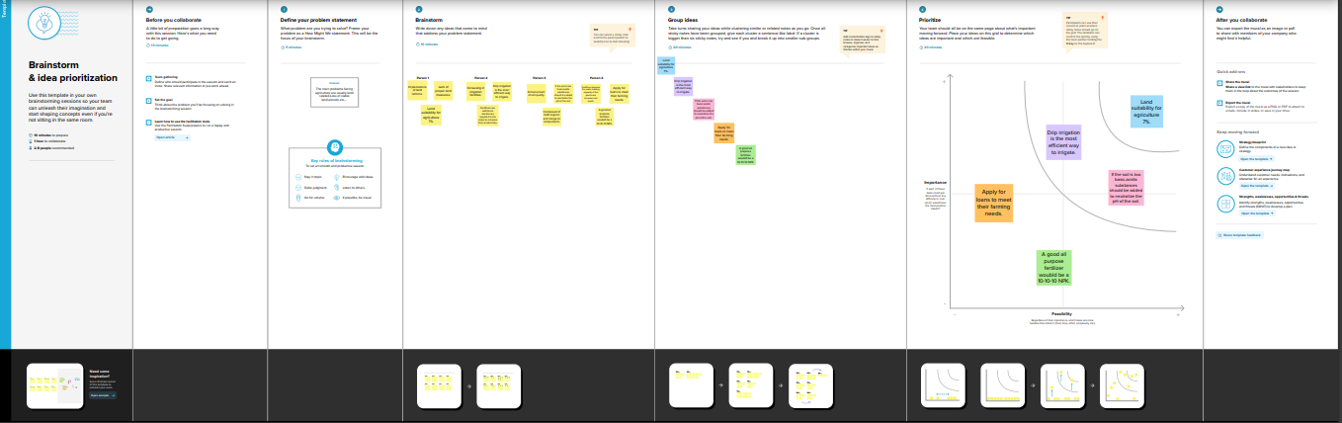

3.RESULT

* Final findings(OUTPUT)

1. COLLECT THE DATASET

2. CONNEECT DATASET WITH TABLEAU

* COLLECT THE DATASET
* A data set is an ordered collection of data.
* CONNECT DATASET WITH TABLEAU
* Start tableau desktop and on the connect pane
* The under search for data, select tableau server
* To connect to tableau server, enter the name of the server and the select connect.

3.DATA PREPARATION

* The data preparation is the data of placing into final solution before freeze drying.
* The data preparation is the data of heat treatment in the final contain.

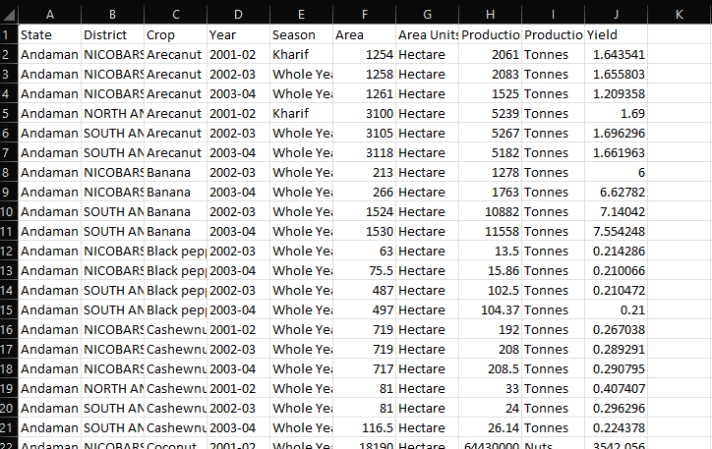

4.DATA VISUALIZATION:

* We introduced graphical representation of any data or information
* Visuals are more effective then text
* Visualized data increases knowledge
* Visual metaphors are a universal language
* People of any spoken are written language can communicate with visual metaphors
* Data has value only when it is processed, analyzed and remembered
* Use this subheading to given graphical representation of data
* Graphical representation like bar chart, pie chart line chart and maps.

5.DASHBOARD:

* The correct use of dashboard UX and graphical excellence principles turn ordinary graphical into extraordinary experiences.

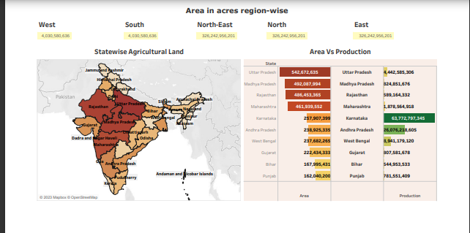

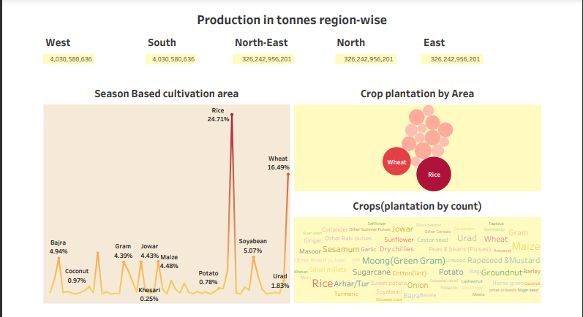

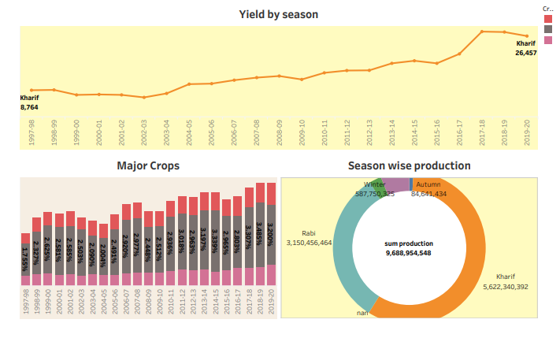

6.STORY:

* A data story is a narrative constructed around a set of data that puts it into context and frames the broader implication.
* A data stories can be told using a variety of mediums, such as reports, interactive and videos.

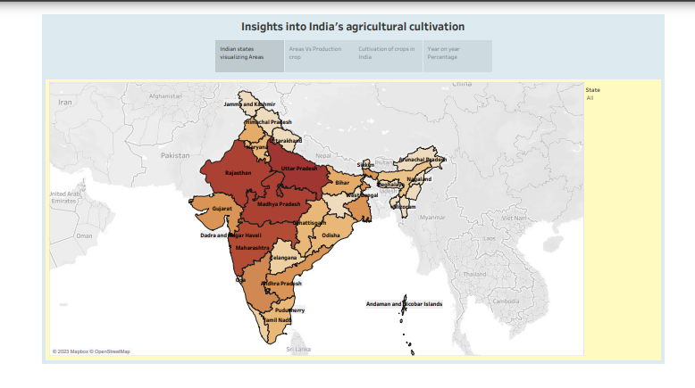

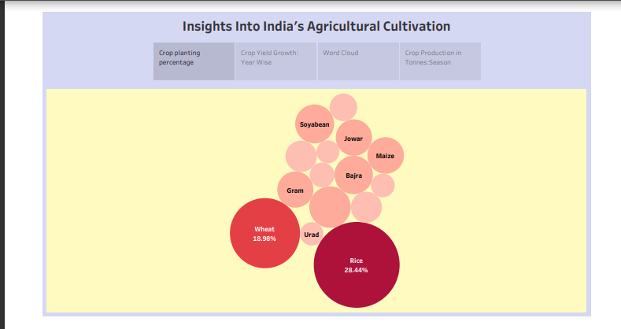

4.ADVANTAGES & DISADVANTAGES

Advantages:

* Agriculture is the backbone of our country’s economy.
* Supplies raw materials to agro-based industries like sugar, jute, cotton textile and vanaspati industries.
* Agriculture is the source of match national income.

Disadvantages:

* Erosion of soil by heavy rain, floods, insufficient vegetation cover etc., reduces farm productivity.
* Intensive farming causes soil degradation and leads to the expansion of new lands.
* Depletion of natural resources.

5.APPLICATIONS

* Agriculture is the primary activity of the nation.
* It is the source of food and fodder.
* It impacts society in many ways.

6.CONCLUSION

* The Indian economy is an agro-economy and depends highly on the agricultural sector.Agriculture has given so much to society.But it has its own pros and cons we can’t overlook.

7.FUTURE SCOPE

* Agriculture sector have an enormous scope in india .
* Agriculture is the most important enterprise in the world.
* Those primary units are consumed by animals and are converted into secondary units like milk,meat,eggs,wool,honey,sillk,etc…

8.APPENDIX

A.SOURCE CODE

* DATASET:

<https://drive.google.com/file/d/1_QKcNhqTKLujmt3KMh6vXlaNu3QHUGLB/view?usp=sharing>

* DASHBOARD 1:

https://public.tableau.com/views/Dashboard1_16958045173720/Dashboard1?:language=en-US&publish=yes&:display_count=n&:origin=viz_share_link

* DASHBOARD 2:

<https://public.tableau.com/views/Dashboard2_16958041726170/Dashboard2?:language=en-US&publish=yes&:display_count=n&:origin=viz_share_link>

* DASHBOARD 3:

<https://public.tableau.com/views/Dashboard3_16959106778510/Dashboard3?:language=en-US&publish=yes&:display_count=n&:origin=viz_share_link>

* STORY 1:

<https://public.tableau.com/views/Story1_16959104078020/Story1?:language=en-US&publish=yes&:display_count=n&:origin=viz_share_link>

* STORY 2:

<https://public.tableau.com/views/Story2_16959096718390/Story2?:language=en-US&publish=yes&:display_count=n&:origin=viz_share_link>